Wiki Instructions for Administrators

Contents
Prerequisites 1
See all the available pages in the wiki 1
Content and User Group Privileges 1
Content approvals 2
How to approve content changes 2
Add new page 2
Upload PDF file and create direct link to it 3
See all the available files in the wiki 3
Upload and embed video in page 3
Add page in the “Navigation” menu 4
Change the main page 4
Categorize pages with automatic indexes (e.g. Glossary) 5
Convert a registered user to administrator 6
Add custom CSS code 6
Rules and Restrictions 6

Prerequisites
In order to accomplish the actions below, you need to be logged in as administrator. You can log in by licking “Anonymous” at the top right corner and then “Log in”.

See all the available pages in the wiki
In order to see all the available pages in the Wiki platform, click on “Special Pages” in the “Wiki Tools” menu at the left side. Then click on “All pages” in the “Lists of pages” section. The pages are displayed below the form.

Content and User Group Privileges
The Wiki has the following user groups:
- Simple visitors (Anonymous)
The simple visitor has the right to modify a page but not to create a new page. The changes he makes on a page are not automatically visible to the rest of the Wiki users and need confirmation from an administrator or a writer for them to be visible. Note: Immediately after saving the changes made by a regular visitor, the changes are shown on the page as a way of confirming that the system has saved the changes, but as soon as the page is refreshed, the page regains its original content and the changes will only be visible after the relevant confirmation from an administrator or from a writer.
- Registered users (Users)
The registered user has the right to modify a page and create a new page. The changes he makes on a page are not automatically visible to the rest of the Wiki's visitors and need confirmation from an administrator or a writer for them to be seen. Note: Immediately after saving the changes made by a simple visitor, the changes are shown on the page as a way of confirming that the system has saved the changes, but as soon as the page is refreshed then the page gets the original content and the changes will only be seen after from the relevant confirmation from an administrator or from a writer.
- Writers
A registered user can belong to the "Writers" user group after a relevant action by an administrator. The writer can modify pages or create new ones. The changes he makes on a page are not directly/automatically visible to other Wiki visitors and he or another writer or administrator can confirm his changes. Also the writer has the right to confirm changes made by a simple visitor or a registered user.
- Administrators
They have full rights and are able e.g. to create pages, modify them, change user rights, etc. The administrator can modify pages or create new ones. The changes he makes on a page are not directly/automatically visible to other Wiki visitors and he or another writer or administrator can confirm his changes. Also the administrator has the right to confirm changes made by a simple visitor or a registered user. The changes that have been made on a page can be seen if the "History" link is selected on the top right, and then in the line from the list of modifications made, the "approve" link is selected.

Content approvals
In order to see information about the page content approvals in the Wiki platform, click on “Special Pages” in the “Wiki Tools” menu at the left side. Then click on “Approved revisions” in the “Lists of pages” section.

How to approve content changes
The writers and administrators are able to confirm new pages or changes to existing pages that are made from themselves, anonymous users, registered users, other writers or administrators. To see and confirm the changes that have been made to a page, select the "History" link in the upper right corner of the page, and then in the line from the list of modifications made, select the "approve" link.
See the following video showing a writer changing a page and confirming his change.

Add new page
In order to create a new page, go to the search bar at the top of the page and write the title of the new page. If the page already exists then Wiki will show immediately the already existing page. If the page, for example “Test”, does not exist then it will show the option to create it. The message to create the new page is “Create the page "Test" on this wiki!” and you need to click on the link “Test”. Add the text in the editor and click on “Save changes”.
(It is not allowed to use the slash / in the titles of the pages.)
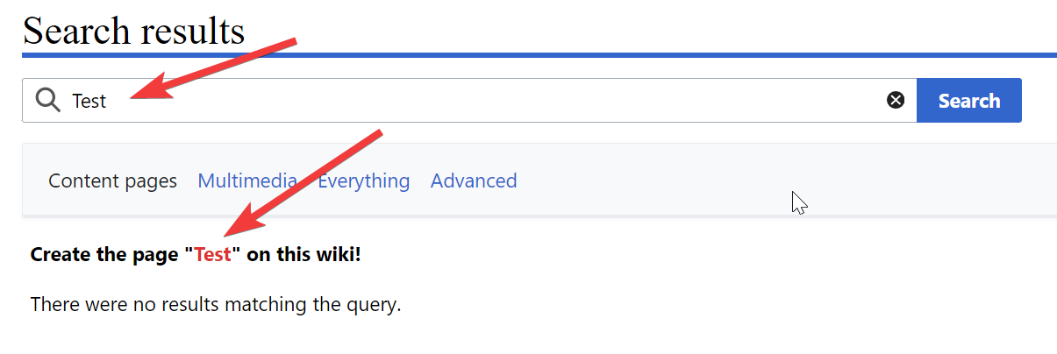
More instructions: https://en.wikipedia.org/wiki/Wikipedia:How_to_create_a_page

Upload PDF file and create direct link to it
In order to upload a PDF file and create a direct link to it please see the following video.
(The file to be uploaded must meet the rules described in the “Rules and Restrictions” paragraph.)

See all the available files in the wiki
In order to see all the available files (PDFs, images etc) in the Wiki platform, click on “Special Pages” in the “Wiki Tools” menu at the left side. Then click on “File list” in the “Media reports and uploads” section.

Upload and embed video in page
To upload a video to the Wiki Platform, click on "Special Pages" in the "Wiki Tools" menu on the left side. Then click "Upload file" under "Media reports and uploads". In the "Source File" section, select "Choose File" and select the video from your laptop. In the “File Description” section, you can edit the destination file name and summary. Pay attention to the instructions at the top of the page. We will need the first example which is "[[File:File.jpg]]". Click "Upload". Then click "Approve".
To embed a video (which has already been uploaded) on a page, you must first locate the video. Click "Special Pages" in the "Wiki Tools" menu on the left side, then click "File List" under " Media reports and uploads ". Locate the video and click on it. Copy the title e.g. "File:Video.mp4". Then find the page that will embed the video and click "Edit Source". In the place you want the video to appear, write [[, then paste the copied title and write ]]. It will be something like "[[File:Video.mp4]]". Click "Save Changes". The video can have a maximum width of up to 640 pixels. If you want the width to be 500 pixels, the previous code will become "[[File:Video.mp4|500px]]".

Add page in the “Navigation” menu
In order to add a new link to the “Navigation” menu which is placed below the logo, go to the search bar at the top of the page and fill in “MediaWiki:Sidebar” and at the new page click on “Edit source”. You need to follow the existing format. The new link is created by the following rule:
** target|link text
where target is the name of the page, e.g. “test” and link text is the title of the link.
After your changes in the editor click on “Save changes”.
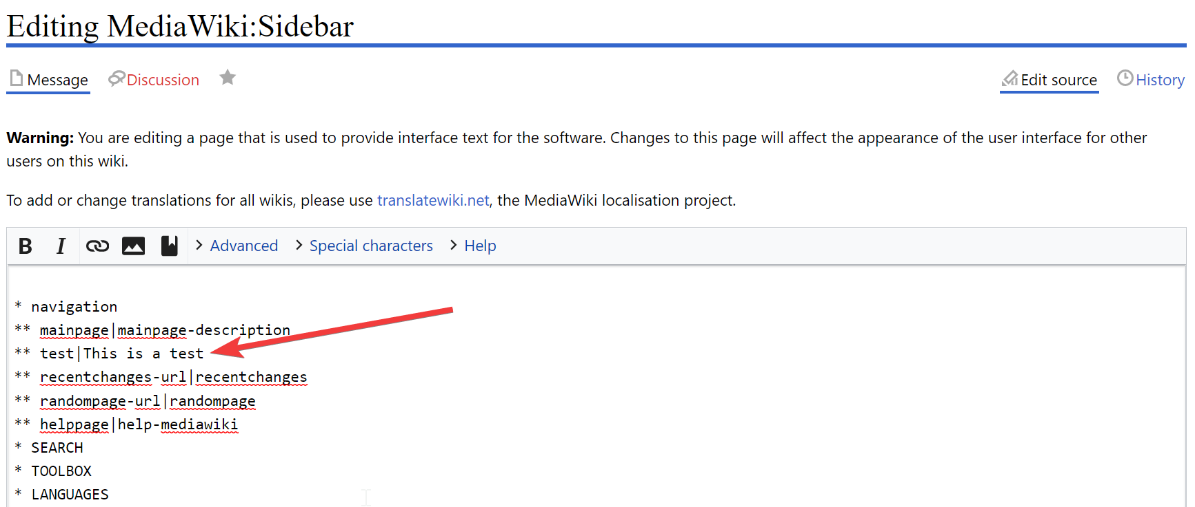
More instructions: https://www.mediawiki.org/wiki/Manual:Interface/Sidebar

Change the main page
In order to change the default page (e.g. when the logo is clicked), go to the search bar at the top of the page and fill in “MediaWiki:Mainpage” and at the new page click on “Edit source”. In the editor fill in the name of the page that you want to become the main page., e.g. “Test”, “Main Page”. After your changes in the editor click on “Save changes”.

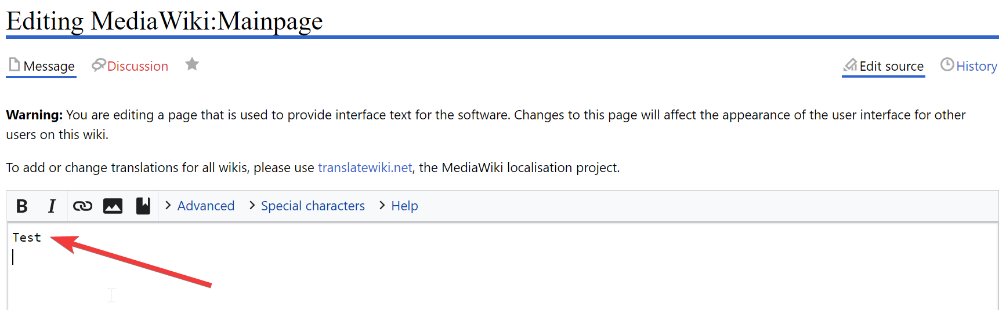
More instructions: https://www.mediawiki.org/wiki/Manual:Main_Page

Categorize pages with automatic indexes (e.g. Glossary)
You can organize your pages by adding them to categories. The advantage of categories is the automatic creation of pages, one for each category, containing indexes that are useful as tables of contents. You can see an example below of a category page.
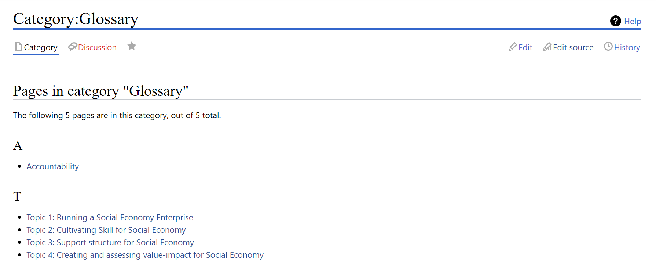
In order to add a page to a category add the following shortcode anywhere in the content of the page using the option “Edit Source” (usually at the top or the bottom):
[[Category:Name]]
where Name is the name of the category. See the example below:
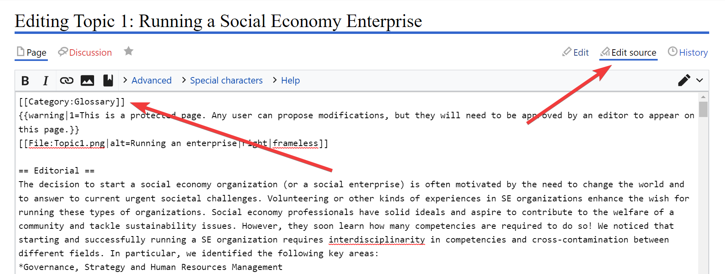
There is no need to do something for the creation of the category. It will be created automatically from the moment the above shortcode is used at least once.
In order to create a link to the actual category page (which will display links to all the pages that belong to it) just add the following shortcode:
[[:Category:Name]]
(Notice the colon before Category)
More instructions: https://www.mediawiki.org/wiki/Help:Categories

Convert a registered user to administrator
To grant admin rights to a registered user, you must also be an admin. Being connected click on “Special Pages” in the “Wiki Tools” menu on the left side, then click on “User rights” under “Users and rights” section. On the new page fill in the username of the registered user you want to be an admin, click on “Load User Groups” and then click on “administrator” and click on “Save user groups”.

Add custom CSS code
In order to add custom CSS code for modifying the appearance of MediaWiki, go to the search bar at the top of the page and fill in “MediaWiki:Common.css” and at the new page you will see the specific page in the list “Page title matches”. Click it and then click on “Edit source” to edit the code. After your changes in the editor click on “Save changes”.

Rules and Restrictions
You need to follow the following rules while adding content to SE4CEs Wiki.
- It is not allowed to use the slash / in the titles of the pages.
- The names of the files (images, PDF etc) that are uploaded to SE4CEs Wiki must:
  - Include only small English letters, numbers and middle dash as apace.
  - Not include special characters, spaces, other language characters than English.

