Wiki Instructions for Administrators

Contents

Prerequisites 1

See all the available pages in the wiki 1

Content and User Group Privileges 1

Content approvals 2

How to approve content changes 2

Add new page 2

Upload PDF file and create direct link to it 3

See all the available files in the wiki 3

Add page in the “Navigation” menu 3

Change the main page 3

Add custom CSS code 4

Rules and Restrictions 4

# Prerequisites

In order to accomplish the actions below, you need to be logged in as administrator. You can log in by licking “Anonymous” at the top right corner and then “Log in”.

# See all the available pages in the wiki

In order to see all the available pages in the Wiki platform, click on “Special Pages” in the “Wiki Tools” menu at the left side. Then click on “All pages” in the “Lists of pages” section. The pages are displayed below the form.

# Content and User Group Privileges

The Wiki has the following user groups:

1. **Simple visitors (Anonymous)**

The simple visitor has the right to modify a page but not to create a new page. The changes he makes on a page are not automatically visible to the rest of the Wiki users and need confirmation from an administrator or a writer for them to be visible. Note: Immediately after saving the changes made by a regular visitor, the changes are shown on the page as a way of confirming that the system has saved the changes, but as soon as the page is refreshed, the page regains its original content and the changes will only be visible after the relevant confirmation from an administrator or from a writer.

1. **Registered users (Users)**

The registered user has the right to modify a page and create a new page. The changes he makes on a page are not automatically visible to the rest of the Wiki's visitors and need confirmation from an administrator or a writer for them to be seen. Note: Immediately after saving the changes made by a simple visitor, the changes are shown on the page as a way of confirming that the system has saved the changes, but as soon as the page is refreshed then the page gets the original content and the changes will only be seen after from the relevant confirmation from an administrator or from a writer.

1. **Writers**

A registered user can belong to the "Writers" user group after a relevant action by an administrator. The writer can modify pages or create new ones. The changes he makes on a page are not directly/automatically visible to other Wiki visitors and he or another writer or administrator can confirm his changes. Also the writer has the right to confirm changes made by a simple visitor or a registered user.

1. **Administrators**

They have full rights and are able e.g. to create pages, modify them, change user rights, etc. The administrator can modify pages or create new ones. The changes he makes on a page are not directly/automatically visible to other Wiki visitors and he or another writer or administrator can confirm his changes. Also the administrator has the right to confirm changes made by a simple visitor or a registered user. The changes that have been made on a page can be seen if the "History" link is selected on the top right, and then in the line from the list of modifications made, the "approve" link is selected.

## Content approvals

In order to see information about the page content approvals in the Wiki platform, click on “Special Pages” in the “Wiki Tools” menu at the left side. Then click on “Approved revisions” in the “Lists of pages” section.

## How to approve content changes

The writers and administrators are able to confirm new pages or changes to existing pages that are made from themselves, anonymous users, registered users, other writers or administrators. To see and confirm the changes that have been made to a page, select the "History" link in the upper right corner of the page, and then in the line from the list of modifications made, select the "approve" link.

See the following video showing a writer changing a page and confirming his change.  


# Add new page

In order to create a new page, go to the search bar at the top of the page and write for the title of the new page. If the page already exists then Wiki will show immediately the already existing page. If the page, for example “Test”, does not exist then it will show the option to create it. The message to create the new page is “Create the page "Test" on this wiki!” and you need to click on the link “Test”. Add the text in the editor and click on “Save changes”.

(It is not allowed to use the slash / in the titles of the pages.)

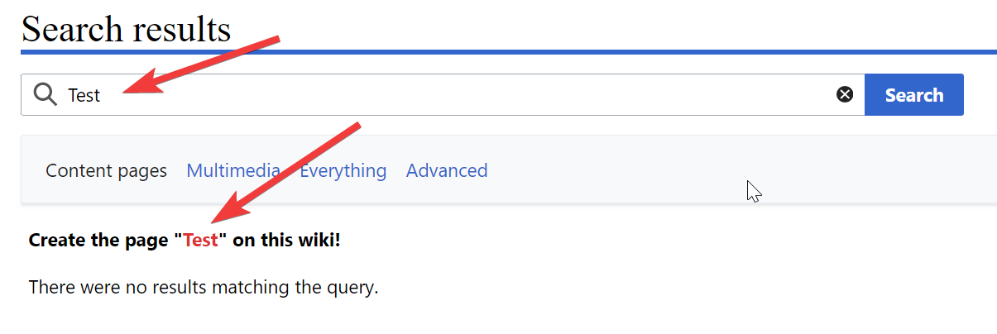

More instructions: <https://en.wikipedia.org/wiki/Wikipedia:How_to_create_a_page>

# Upload PDF file and create direct link to it

In order to upload a PDF file and create a direct link to it please see the following video.

(The file to be uploaded must meet the rules described in the “Rules and Restrictions” paragraph.)



# See all the available files in the wiki

In order to see all the available files (PDFs, images etc) in the Wiki platform, click on “Special Pages” in the “Wiki Tools” menu at the left side. Then click on “File list” in the “Media reports and uploads” section.

# Add page in the “Navigation” menu

In order to add a new link to the “Navigation” menu, go to the search bar at the top of the page and fill in “**MediaWiki:Sidebar**” and at the new page click on “Edit source”. You need to follow the existing format. The new link is created by the following rule:

** target|link text

where target is the name of the page, e.g. “test” and link text is the title of the link.

After your changes in the editor click on “Save changes”.

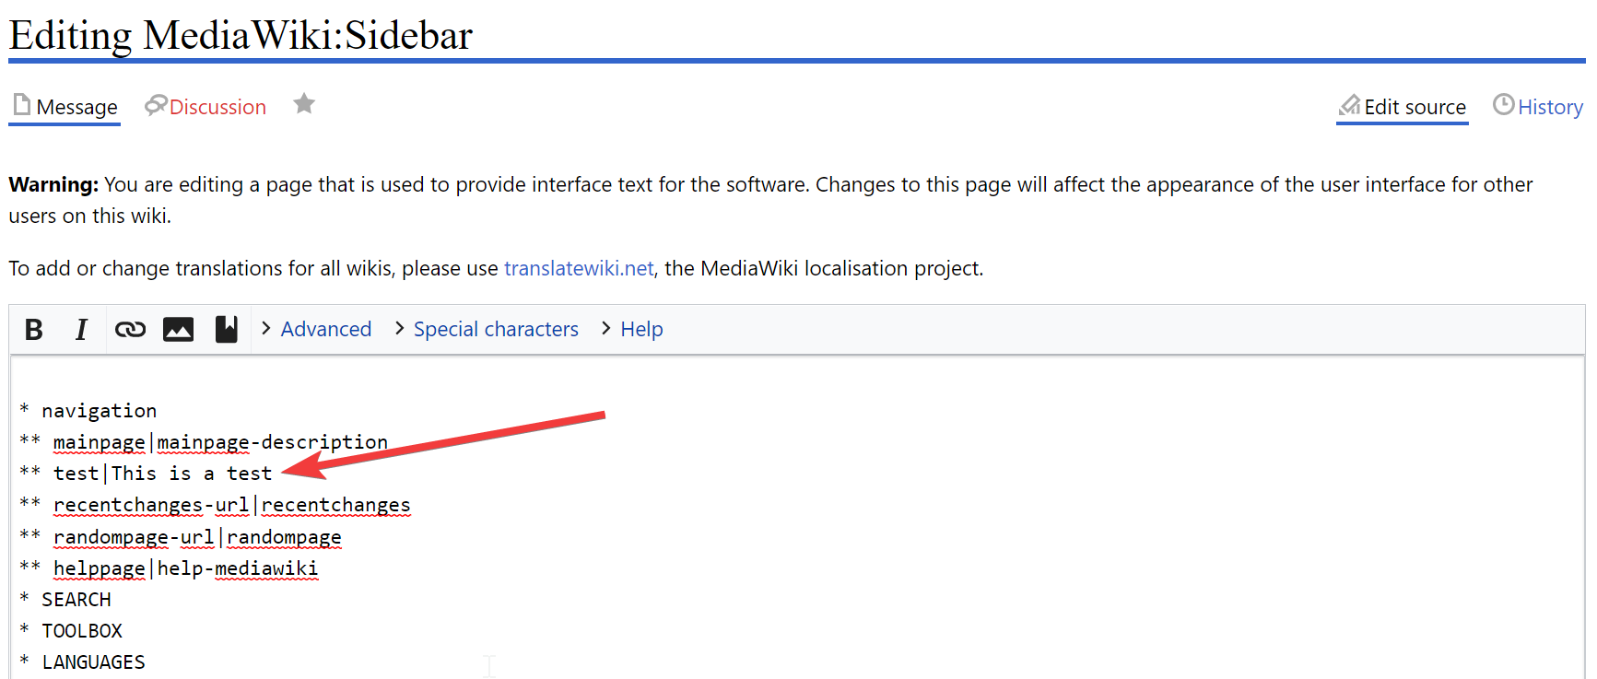

More instructions: <https://www.mediawiki.org/wiki/Manual:Interface/Sidebar>

# Change the main page

In order to change the default page (e.g. when the logo is clicked), go to the search bar at the top of the page and fill in “**MediaWiki:Mainpage**” and at the new page click on “Edit source”. In the editor fill in the name of the page that you want to become the main page., e.g. “Test”, “Main Page”. After your changes in the editor click on “Save changes”.

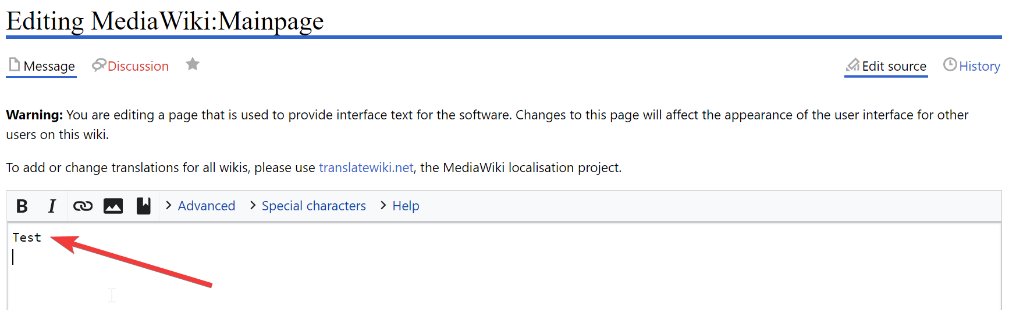

More instructions: <https://www.mediawiki.org/wiki/Manual:Main_Page>

Convert a registered user to administrator

To grant admin rights to a registered user, you must also be an admin. Being connected click on “Special Pages” in the “Wiki Tools” menu on the left side, then click on “User rights” under “Users and rights” section. On the new page fill in the username of the registered user you want to be an admin, click on “Load User Groups” and then click on “administrator” and click on “Save user groups”.

# Add custom CSS code

In order to add custom CSS code for modifying the appearance of MediaWiki, go to the search bar at the top of the page and fill in “**MediaWiki:Common.css**” and at the new page you will see the specific page in the list “Page title matches”. Click it and then click on “Edit source” to edit the code. After your changes in the editor click on “Save changes”.

# Rules and Restrictions

You need to follow the following rules while adding content to SE4CEs Wiki.

1. It is not allowed to use the slash / in the titles of the pages.
2. The names of the files (images, PDF etc) that are uploaded to SE4CEs Wiki must:
   1. Include only small English letters, numbers and middle dash as apace.
   2. Not include special characters, spaces, other language characters than English.